**IMPLEMENTATION OF AN APPLICATION USING**

**JAVA FX**

**IDEA-INDIAN PREMIER LEAGUE**

**GAME ANALYSIS**

Nujhat Farhana shaik- [nshaik4@hawk.iit.edu](mailto:nshaik4@hawk.iit.edu)

Amreen Siddiqua – [asiddiqua2@hawk.iit.edu](mailto:asiddiqua2@hawk.iit.edu)

**CONTENTS:**

Introduction ...............................................................................................................................................01

Login Credentials……………………………………………………………………………………………………………………………………01

Technologies Used (Front-End and Back-End) ............................................................................................02

Functional requirement of this project ......................................................................................................02

output ........................................................................................................................................................03

Extra Credit:

Class diagram……………….………………………………………………………………………………………………………………….…...11

Use Case Diagram….……………………………………………………………………………………………………………………………...12

ER Diagram .................................................................................................................................................13

Password Protection ……………….…………………………………………………………………………………………………………….14

(Password Hashing)

GitHub Repository….………………………………………………………………………………………………………………………….….14

Working of Jar file in main application………………… ……………………………………………………………………………….14

Introduction

Cricket is a game similar to Baseball highly popular in England, Australia, India and other south Asian countries:

**Indian Premier League (IPL)** is a professional Twenty20 cricket league in India, founded in 2008. Top cricket players from all over the world are drawn to it, making it one of the most lucrative and well-known sports leagues in the world. To provide a consolidated and effective system for maintaining and analysing data linked to the Indian Premier League, a database management system (DBMS) along with JavaFX based Object Oriented programming concept-based User Interface have been developed. The IPL generates a ton of data, including information about players, teams, match times, and venues. This data can be arranged and kept in a structured, readily accessible way with the aid of a DBMS. The following are some use cases considered here for the study:

**Login**: Admin or Team level users can login using this page. Admin will have complete access. Can do add edit and delete operations in the application. Other users can only login and view the match schedules published by the admin.

**Registration**: Team level user can register providing their details along with username and password of their choice. Once successfully registered, can login and view the match schedules.

**Manage Match Schedules**: Admin can Add/ Delete Match Schedules. Also, can update the match outcomes.

**View Match Schedules**: All the published match schedules can be viewed by logged in user. Admin can view all schedules irrespective of team in a Table View format. Similarly, team level users can view but only the schedules of their respective team.

This is designed with a multi-tier architecture, which separates the application into front-end, back-end, and data base components.

**Login Credentials:**

**Admin:**

User name: admin1

Password: admin1

**User:**

User name: Farhana

Password:12345

**Technologies Used:**

* **Front-End Architecture**: The front-end is built using JAVA FX and is responsible for rendering the user interface.
* **Back End Architecture:** The back-end architecture handles the incoming requests from front end architecture and communicates with data base.
* **Data-base Architecture:** The database architecture consists of tables and views that store the application data. The tables are designed to store player data, match data and team data. Views are used to provide a more meaningful representation of the data to users. The data base is accessed by the back-end architecture.
* **Deployment Architecture:** The application is deployed and designed to be scalable and can handel multiple users at the same time.

**Functional requirement of this project:**

**1**.**User Authentication**: The application should allow users to create an account and log in with their credentials. the user authentication system should ensure that only authorized users have access to the application.

2.**Admin Dash board:** Admin dash board allows the administrator to perform CRUD operations (create, read, update, delete) on the player, team, and match the data.

3.**Player data management:** This application should allow the admin to manage player data, including adding new player details, and deleting players. The application should also allow to view player statistics and performance reports.

SNAPSHOTS OF THE OUTPUT:

LOGIN PAGE:

1. Show a successful login for an admin.
2. Login page with admin credentials:

This is the home page for admin

1. Show some update performed by the admin for the first record entered into the db.

Match Schedule Page:

Adding a match schedule detail of the first record:

After adding the details, this will appear in your homepage

Admin has added another match schedule which is

It will appear in your home page

1. Show the deletion of the last record by the admin entered in the db.

Now we will perform the deletion operation of the last record which is CSK VS RCB

Now we will see the adding i.e., Add team by admin

Admin has added a team and then you will get a popup as :

Now the details of a team we can see it in the data base:

Some crud operations have been done by the admin.

1. Showing a successful login for a regular user.

Now we will the User registration part and user access.

User has registered for the team CSK, after registering you will get the popup as

Now we will login as user:

The home page for the user is as follows:

Because the user has registered as CSK, so user can only see the Matches related to CSK only.

And coming to match schedule page and Add team page you will not access for that it has access only for the admin.

EXTRA CREDIT:

**1)class diagram**

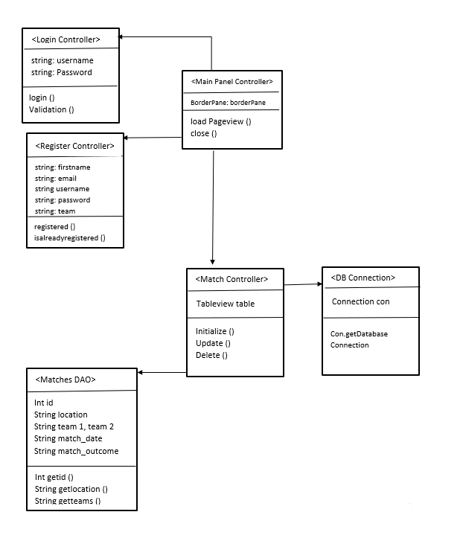

2)Use Case Diagram:

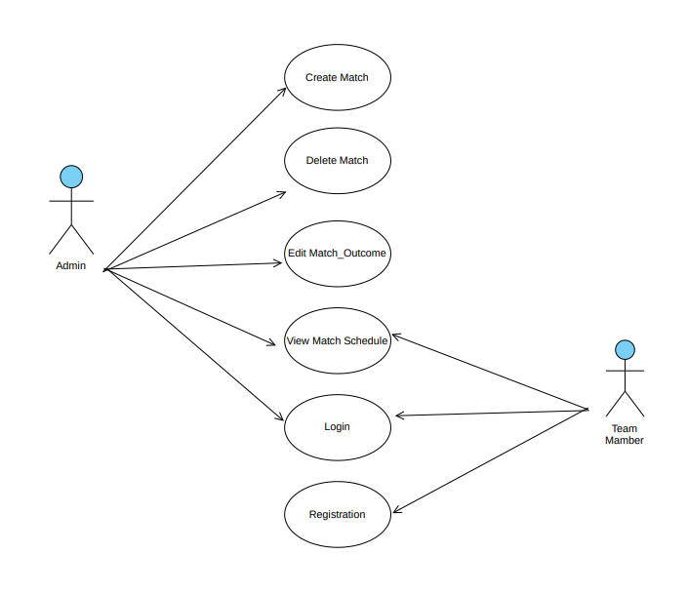

3)ER Diagram:

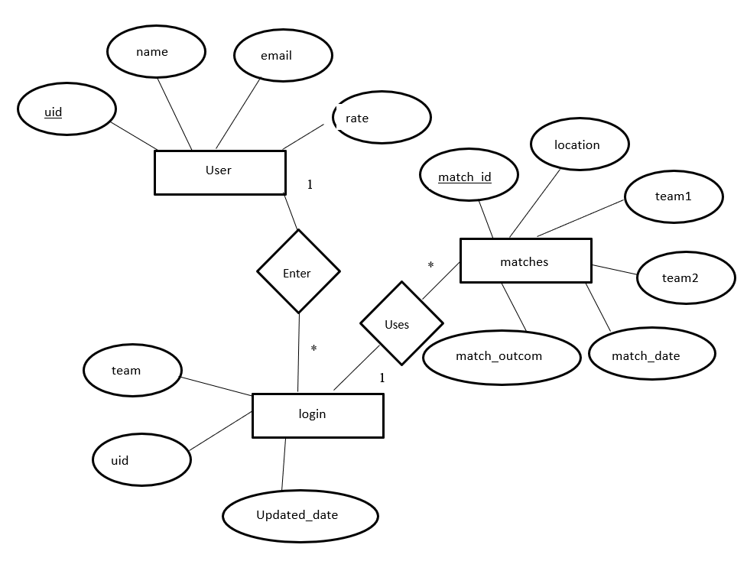

EXTRA CREDIT:

PASSWORD PROTECTION (PASSWORD HASHING)

PASSWORD HAS ENCRYPTED:

EXTRA CREDIT:

GITHUB REPOSITARY:

EXTRA CREDIT:

Include a working .jar file of your main application file (+10)

We have tried the jar file with java jdk 20 version not the jdk 8 version

So we have run the command prompt as follows:

**cd C:\Users\siddi\OneDrive\Desktop**

**"C:\\Program Files\\java\\jdk1.8.0_241\\bin\\java" -jar ipl.jar**

We have included the jar file in the code and we have run the command prompt as shown above

We got the login page .

